**Class 8 Lab questions**

#1. WAP to print the following pattern for n rows. Ex. for n=5 rows

1

0 1

1 0 1

0 1 0 1

1 0 1 0 1

Code:

#include <stdio.h>

int main()

{

int a285,b285,d285;

printf("enter the value:\n");

scanf("%d",&a285);

printf("\n");

for(b285=1;b285<=a285;b285++)

{

    for(d285=1;d285<=b285;d285++)

        printf("%d ",(a285+b285+d285)%2);

        printf("\n");

}

return 0;

}

Output:

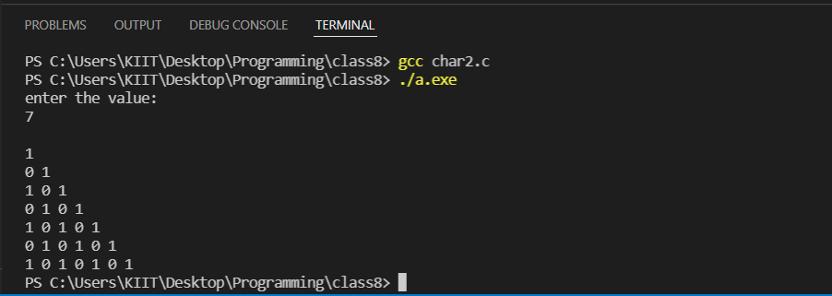

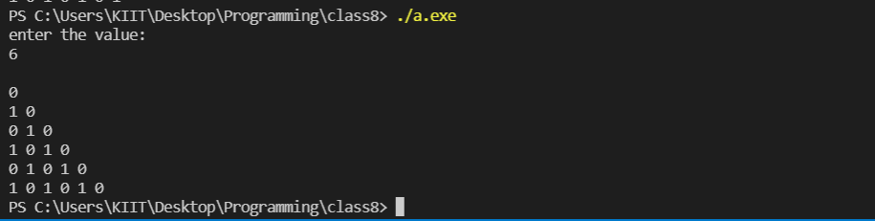

#2. WAP to print the following pattern for n rows. Ex. for n=5 rows

A

A B

A B C

A B C D

A B C D E

Code:

#include<stdio.h>

int main()

{

int a285,b285,d285;

char ch285;

printf("enter the value:\n");

scanf("%d",&a285);

printf("\n");

for(b285=1;b285<=a285;b285++)

{

    ch285='A';

    for(d285=1;d285<=b285;d285++)

       {printf("%c ",ch285);

        ch285=ch285+1;}

    printf("\n");

}

return 0;

}

Output:

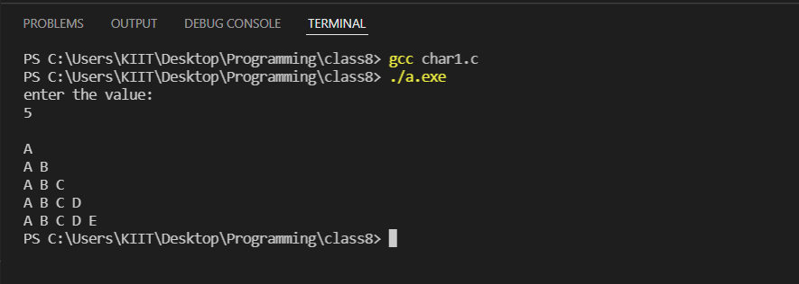

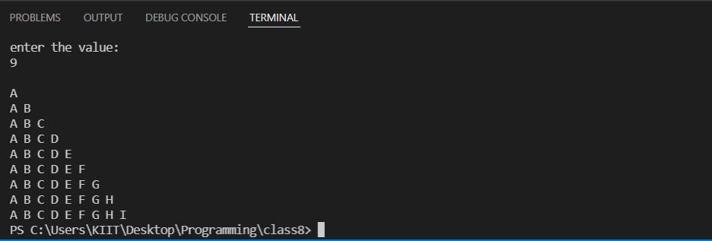

#3. Series 1 + 32/3 3 + 52/5 3 + 72/7 3 + ... till N terms

Code:

#include <stdio.h>

#include <math.h>

int main()

{

    int i285,N285;

    float sum285;

    int count285;

    printf("Provide total number of terms=>");

    scanf("%d",&N285);

    sum285=0.0f;

    count285=1;

    for(i285=1;i285<=N285;i285++)

    {

        sum285 = sum285 + ((float)(pow(count285,2))/ (float)(pow(count285,3)));

        count285+=2;

    }

    printf("Sum of the series is: %f\n",sum285);

    return 0;

}

Output:

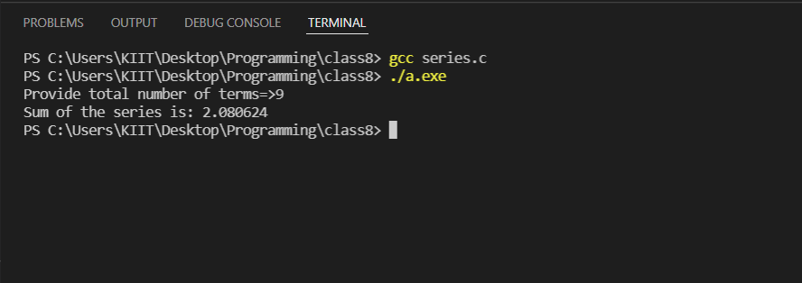

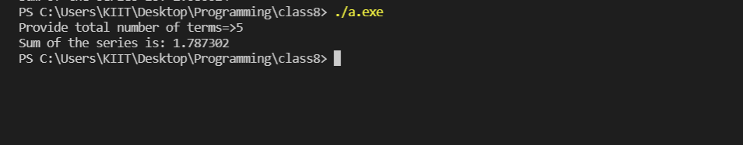

#4. WAP to form a pyramid of numbers for a given number. Ex. for number 4

Code:

#include <stdio.h>

int main()

{

int n285,i285,j285,k285;

   printf("\nEnter a number to form a pyramid =>");

    scanf("%d",&n285);

    printf("\n");

    for(i285=1;i285<=n285;i285++)

    {

        for(j285=1;j285<=n285-i285;j285++)

            printf("  ");

        for(k285=1;k285<=i285;k285++)

            printf("%d ",k285);

        for(k285=i285-1;k285>0;k285--)

            printf("%d ",k285);

        printf("\n");

    }

return 0;

}

Output:

